**Experiment No : 05**

**Title : Write a program in Python to use try  except statement.**

**Problem statements:**

a. Check Divide by zero exception.

b. “raise” an exception for Wrong enrolment number.

**Theory:**

Python has many built-in exceptions that are raised when your program encounters an  error. When these exceptions occur, the Python interpreter stops the current process and passes it  to the calling process until it is handled. If not handled, the program will crash.

If never handled, an error message is displayed and our program comes to a sudden unexpected  halt.

**Using try-except statements:**

In Python, exceptions can be handled using a try statement.

The critical operation which can raise an exception is placed inside the try clause. The code that  handles the exceptions is written in the except clause.

A try clause can have any number of except clauses to handle different exceptions, however, only  one will be executed in case an exception occurs.

**Raising Exceptions in Python:**

In Python programming, exceptions are raised when errors occur at runtime. We can also manually  raise exceptions using the raise keyword.

Try the following snippet of code, which finds reciprocal of a number. 

**Code :**

**Code without try-except block:**

a=10

b=0

print(a/b)

**output :**

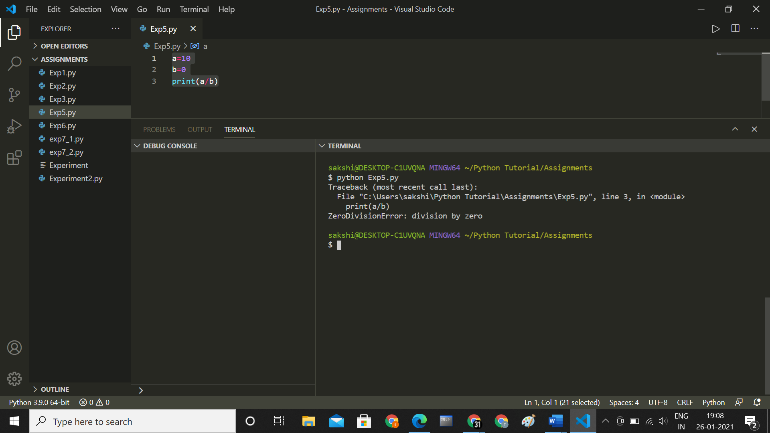

**Code with try-except block :**

a=10

b=0

try :

    print(a/b)

except:

    print('cannot divide a number by zero')

**output:**

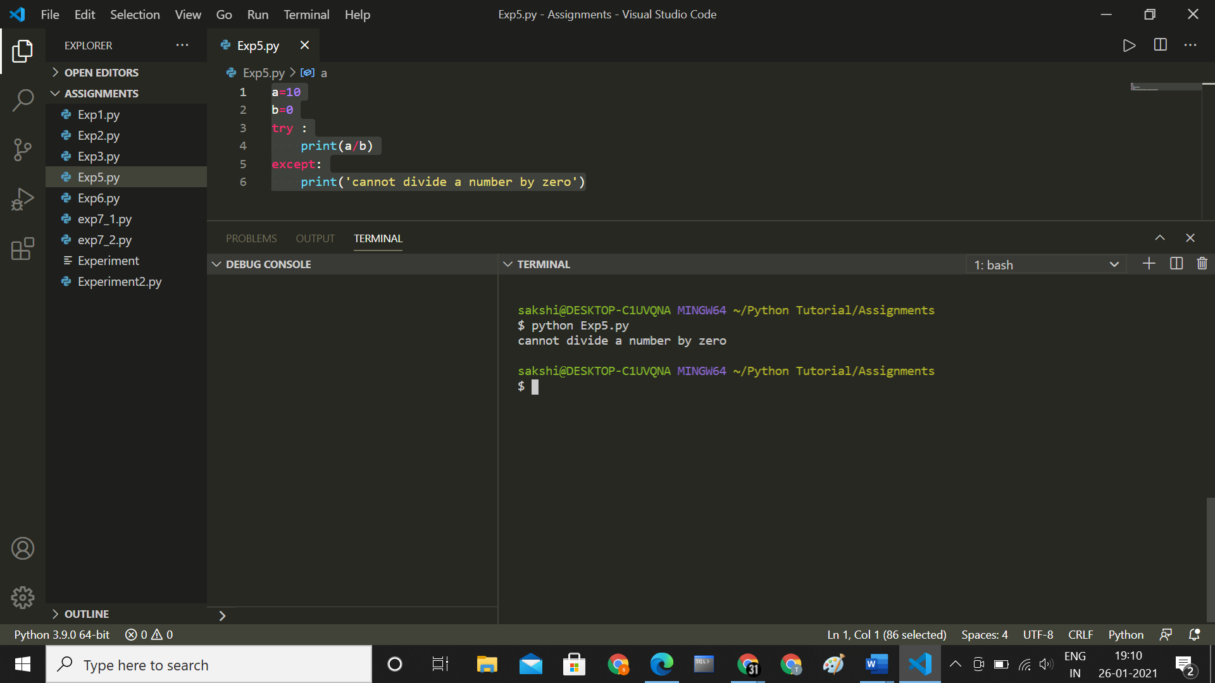

**b. “raise” an exception for Wrong enrolment number.**

While giving input as zero, the  program generates

“ZeroDivisionError: division by  zero” error. To avoid such  interruption in program, try except statements can be used. 

**Code :**

import re

enroll_number=input("Enter Enrollment Number")

if *bool*(re.match("SS19CO[0-9][0-9][0-9]", enroll_number)) or *bool*(re.match("FS19CO[0-9][0-9][0-9]",  enroll_number)):

    print(enroll_number)

else:

    raise *Exception*("Wrong enrollment number")

**output :**

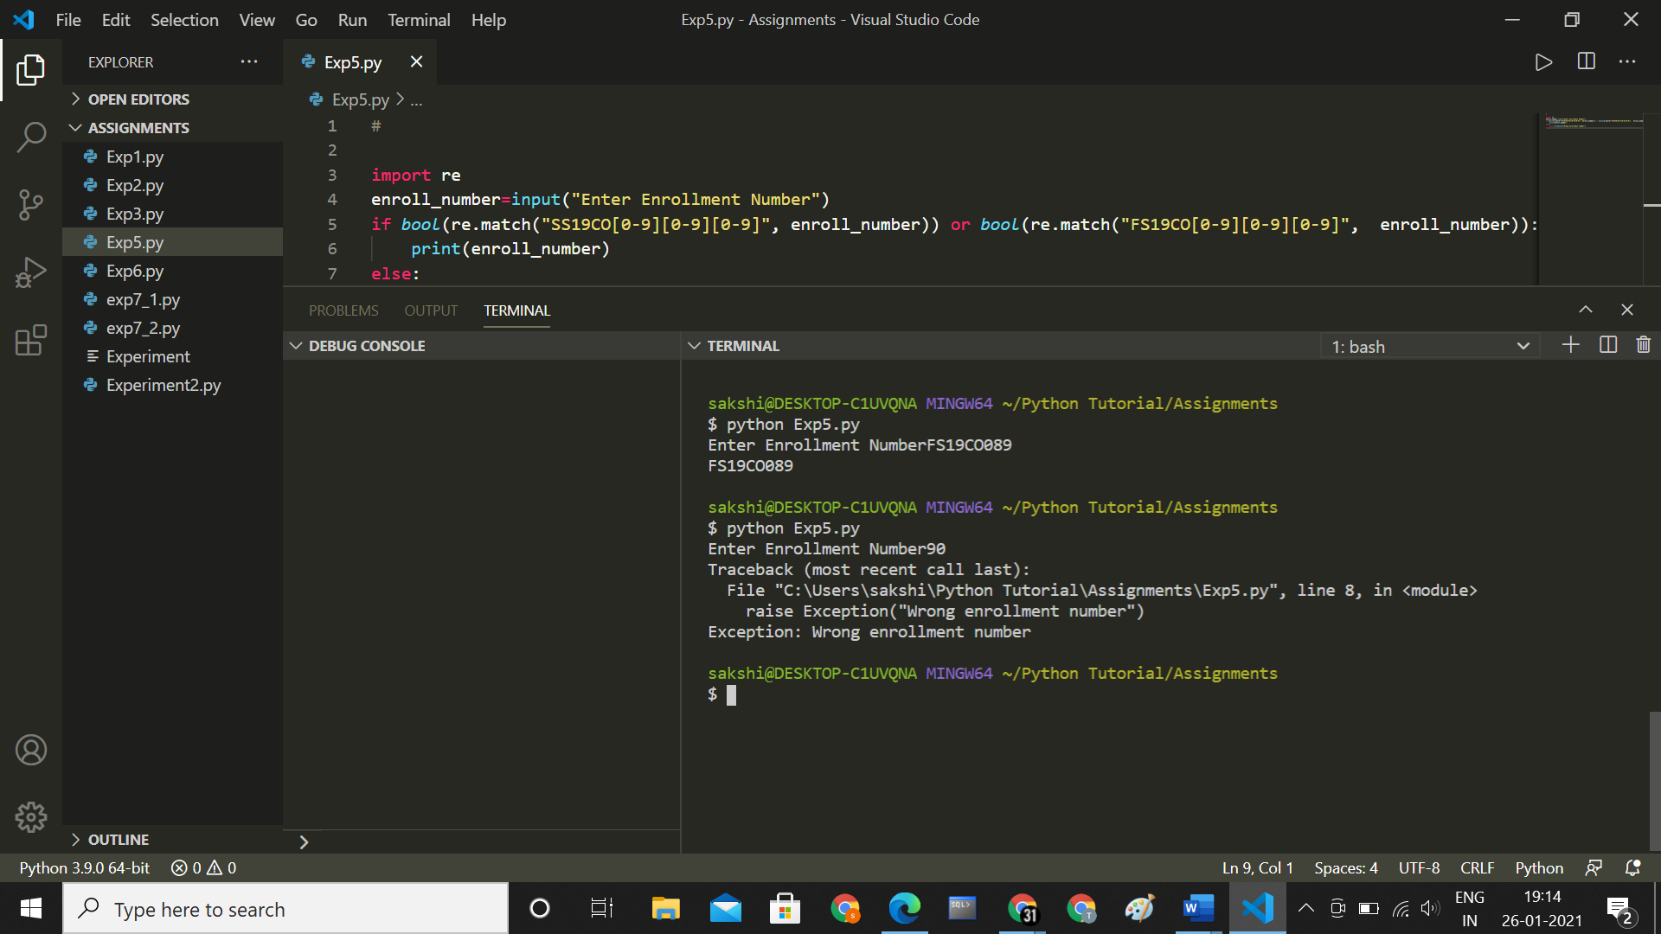

**Conclusion :**

**Thus we have studied and understood how to write python program using try -except statements .**